**UNCOVERING THE GAMING INDUSTRY’S HIDDEN GEMS: A COMPREHENSIVE ANALYSIS OF VIDEO GAME SALES**

**INTRODUCTION**

**OVERVIEW:**

over the past 40 years, a veritable industry has grown up around the design, development, and delivery of

video games for home video game consoles and the personal computer (PC). Collectively called the

“video game industry”, these endeavors have greatly evolved from a cottage industry in the 1970s to a

goliath that rivals the film industry for household entertainment expenditures. As the U.S. is the world’s biggest

video games market and manufacturer, the U.S. video game market is now worth over $20 billion annually in

software and hardware sales, which is more than four times the market size in the 1990s (Chatfield, 2010).

Furthermore, video games are so entrenched in the daily lives of many people who are buying games in a variety of

platforms (e.g., mobile smart phones, game consoles, PCs, etc.), are increasingly playing online (via the Internet),

and are willing to pay for the privilege to do so. Blizzard Entertainment’s World of Warcraft, for instance, has over

11 million player/subscribers worldwide and over $1 billion per year in revenues. Microsoft’s Xbox Live gaming

service claims 20 million subscribers reaching 39 million gaming consoles and 10-million non-gaming accounts

used solely for social networking benefits (Grant, 2010). Career options in the video game industry are also very

healthy with 254 U.S. colleges and universities in 37 U.S. states nowoffering courses and degrees in computer and video game design, programming, and art (Chatfield, 2010).

**PURPOSE:**

Overall, a trend continues where video games are not just a fad or for the young, but increasingly an activity that incorporates nearly everyone. Sixty-eight percent of American households now play video games and many of these are online players; additionally, 43% of online U.S. game players are female. Moreover, the U.S.

military spends around $6 billion a year on virtual and simulated training programs, based around video games and virtual worlds in an offshoot of the industry dedicated to serious games (Aldrich, 2009; Reeves & Read, 2009). Perhaps the most remarkable aspect of the advent of the video game industry is the rapid rise of the breadth

and scope of the industry itself. Even with its own humblebeginnings, the movie industry was recognizable as such at an early stage.However, video games languished as a cottage industry untiljust the last 15 years, with the first decade of the 21st

Century witnessing meteoric gains.

There are several relevant streams of literature related to the topic of video game sales and the nature of the video games industry. First, it is important to state that the video game industry is both an entertainment and a software industry, so there are different theoretical bases that can be used to shed light on this subject. As our

interest is in the determinants of video game sales.

PROBLEM DEFINITION AND DESIGN THINKING

EMPATHY MAPPING

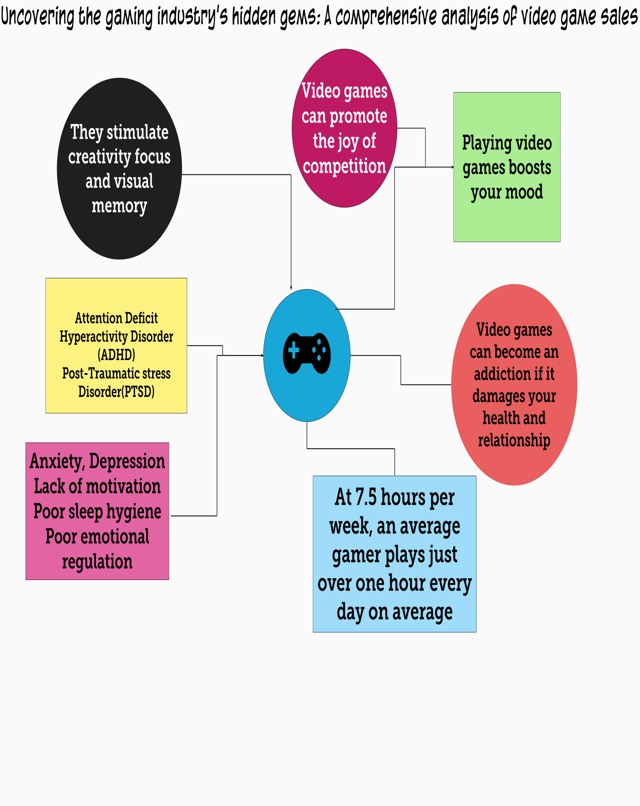

**BRAINSTROMING AND IDEATION**

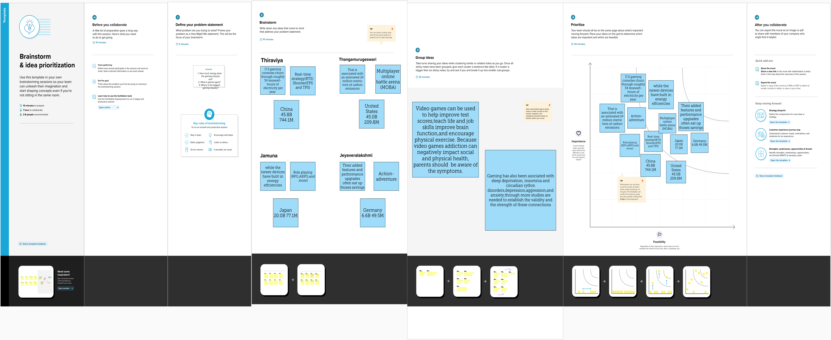



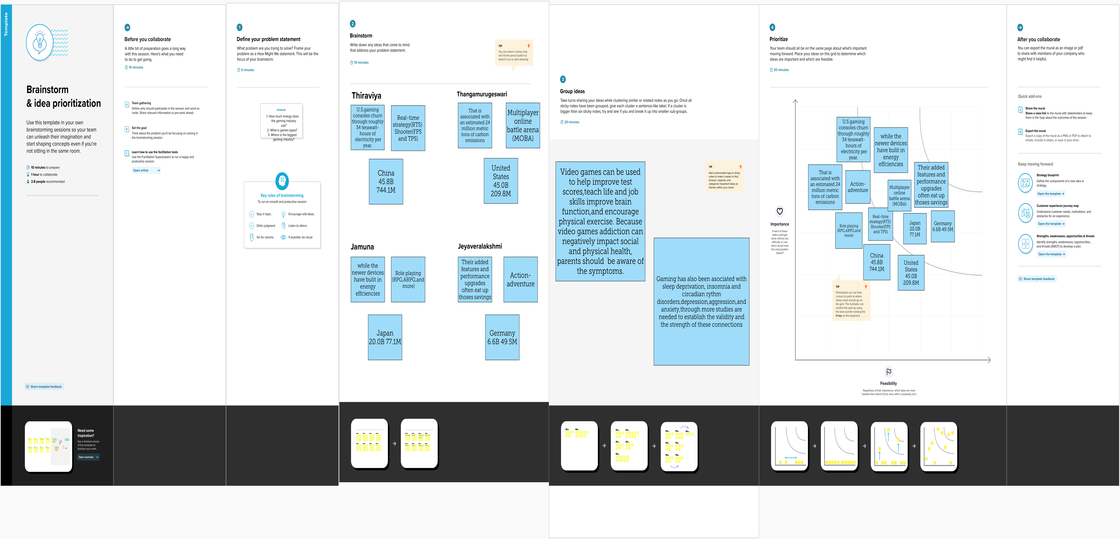

RESULT

ACTIVITY 1.1

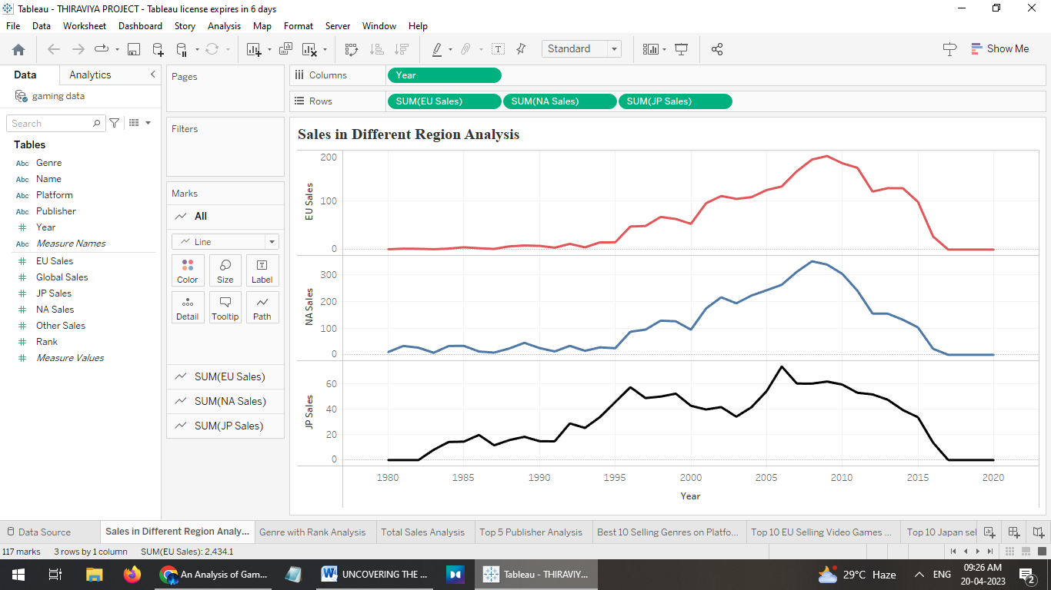

ACTIVITY 1.2

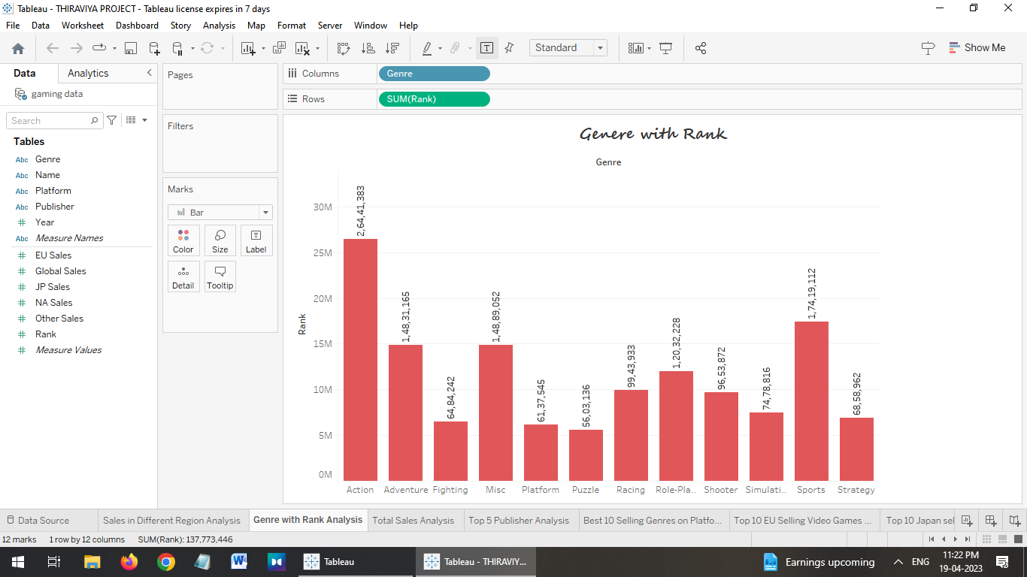

ACTIVITY 1.3

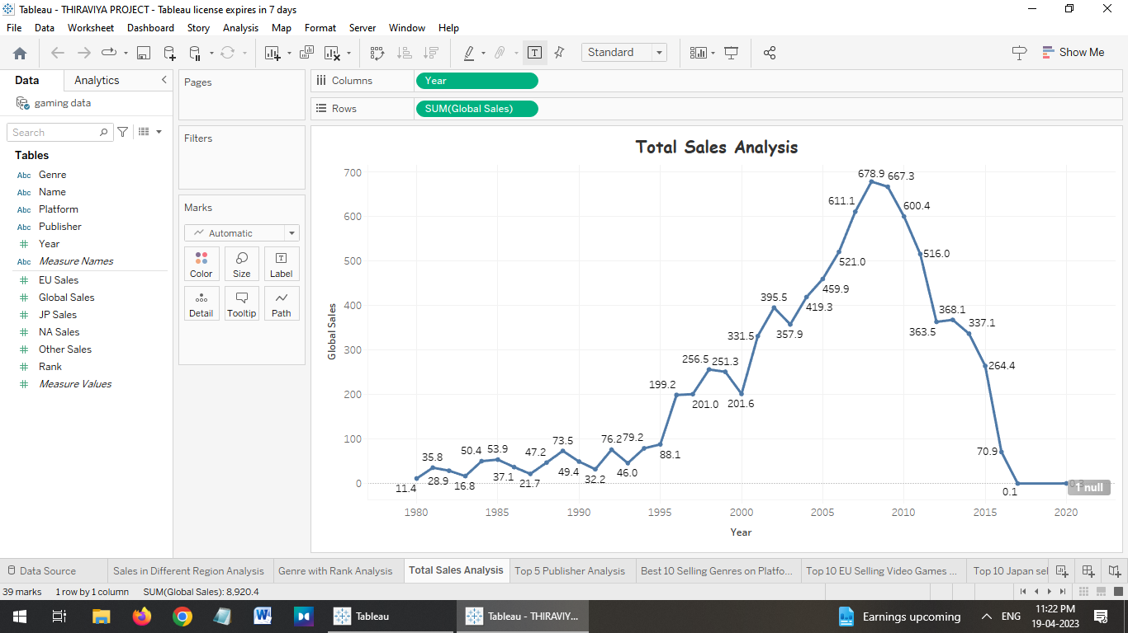

ACTIVITY 1.4



**ACTIVITY:1.5**

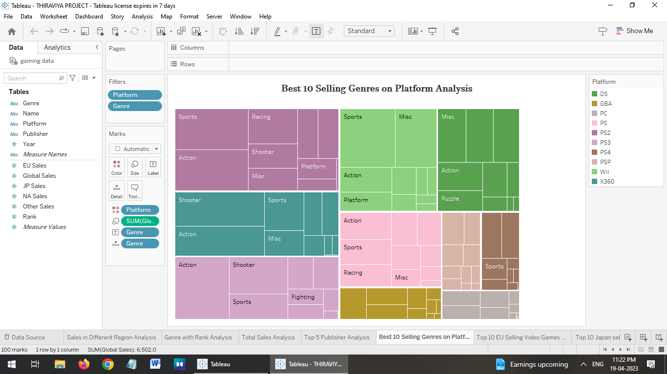

ACTIVITY:1.6



**ACTIVITY:1.7**

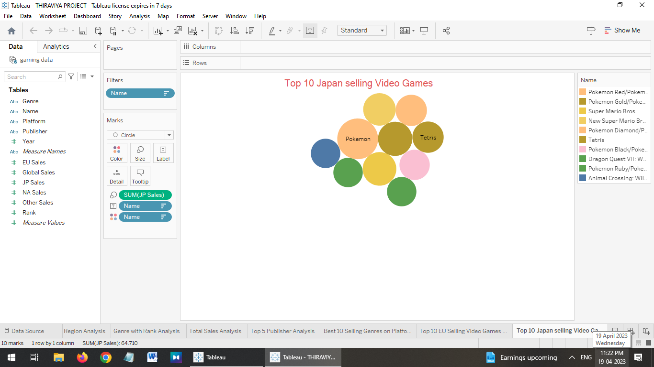

ADVANTAGES:

Video games provide a lot of benefits for people of all ages. They can help people improve their hand-eye coordination, problem-solve, and learn new strategies. They can also provide hours of fun and entertainment. Some people even use video games to relieve stress and anxiety.

**Improves dexterity –** Video games can improve manual dexterity. Many video games require the player to use their hands and fingers in precise ways.

**Games can increase your brain’s gray matter –** Video games can increase your brain’s gray matter. A study published in the journal Neurology found that people who played video games for at least two hours a week had an increase in gray matter in the hippocampus, which is responsible for memory and spatial navigation

**DISADVANTAGE:**

There are many disadvantages to playing video games. Some of the most common are that they can be addictive, lead to poor physical and mental health, and can take up a lot of time. They also can be expensive, which can limit people’s ability to play them. Other cons of video games are as follows:

**Extremely addictive –** Video games have become increasingly popular over the years, but there are some disadvantages to playing them. One of the most common is dopamine addiction.

**Affects Emotions –** Video games can have a lot of advantages, but they can also have some disadvantages. One disadvantage is that video games can affect emotions in a negative way.

**Can cause Repetitive Stress Injuries –** Video games can be a lot of fun, but they can also cause repetitive stress injuries (RSI). Playing video games for too long can cause your hands, wrists, and shoulders to hurt.

**APPLICATIONS:**

Video games came into the limelight with the birth of the original game console. In 1889, the creation of the Nintendo Company brought video games into a climax era, such as the well-known Mario, which has sold more than 373 million copies to date [1]. The video game entered the multimedia era with the competition of 16-bit consoles and the 3D era with the competition of 32-bit consoles. After entering the 21st century, Microsoft, Nintendo, and Sony became the three dominant players of video games. video game entered China in the late 20th century and has experienced four eras so far: the preparatory era, the leap forward era, the stable era and the multi-platform era [2]. In recent years, with the rapid development of e-sports industry [3], major businesses have started to join the game industry, and video game has entered the golden period of commercial development. Public demand for video games has also increased dramatically, and due to the global outbreak of the New Coronary Pneumonia in 2020, video games have become a mechanism for coping with anxiety in an epidemic setting and one of the most attractivetechnological interventions to address the mental health effects of New Coronary Pneumonia [4]. Video games are favored by users and capital. However, in the face of the huge number of video game products, how merchants can use reasonable marketing strategies to increase product revenue and how users can choose products to get more benefits are important issues to be tackled. In addition, data analysis is needed to conduct commercial research on video games and obtain large-scale, diversified, personalized and real-time research results [5, 6], which is more conducive to the mining of various data information of users. This shows that it is a worthwhile direction to investigate the commercial application of video games based on data analysis. In this paper, the author crawls vgchartz.com to collect video game data samples. The statistical processing and exploratory analysis are mainly conducted on the game product release platform, genre, and release year data. The KMeans algorithm is used to classify game products according to sales, and the corresponding business strategies are proposed for platforms, publishers, and users in conjunction with the market to stimulate marketing and market economy.

**CONCLUSION:**

1.Sales in different region Analysis

2.Genre with rank Analysis

3.Total Sales Analysis

4.Top 5 publishers Analysis

5.Best 10 selling video games Analysis

6.Top 10 EU selling video games Analysis

7.Top 10 japan selling video games Analysis

8.Top 10 NA selling vedio games

**Future Scope:**

The future of gaming industry in India looks promising. Some of the main changes that can boost the industry in future include – increase in freemium games in order to create better economics for companies, boost in e-sports division to increase online gaming, development of such games having content according to local tastes, improving age and gender parity among gamers, more focus on gamification and other emerging technologies. Also, courses in gaming and game development should increase in order tofoster new career paths in gaming and to build up a considerable talent pool in the sector. The above changes look inevitable with the current pace of growth of the industry and India should look to capturemany more opportunities that come with the growth of this industry

Gaming in India is not governed by any exclusive act or statute. The Constitution of India deals with gaming and gambling in the same light. It empowers each state to make their own laws regarding the same. Fantasy team games that involve putting money on the line are banned in some states like Tamil Nadu, Telangana and Andhra Pradesh. According to the Supreme Court of India, games where luck dominates skill are not allowed and games where skill trumps luck are permitted. However, this is a very controversial argument owing to the subjectivity in characterizing a game.

**APPENDIX:**

**SOURCE CODE**

For further information click the link below

Dashboard

## <https://public.tableau.com/views/dashboard_16818842943080/VideoGameSalesDashboard?:language=enUS&:display_count=n&:origin=viz_share_link>

## Story:

## [https://public.tableau.com/views/story_16818845442300/VideoGamesSalesStory?:language=en US&:display_count=n&:origin=viz_share_link](https://public.tableau.com/views/story_16818845442300/VideoGamesSalesStory?:language=en-US&:display_count=n&:origin=viz_share_link)

## Web application:

## <file:///C:/Users/ELCOT/Downloads/Gp/index.html>